# GUI prototype

Server Side

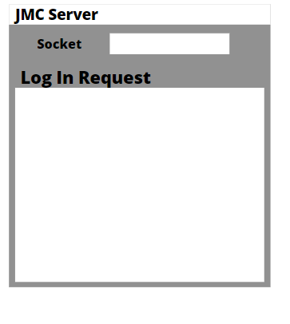

Client you have to log in first

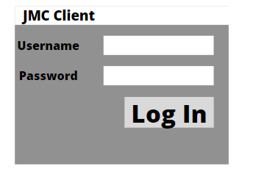

Then you get to access

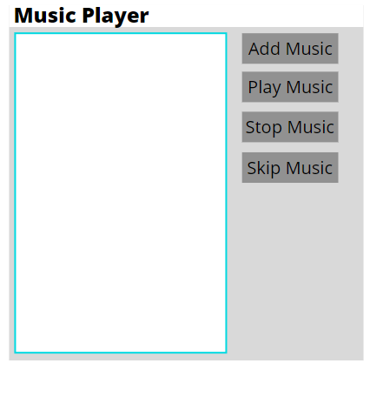

# UML Diagram

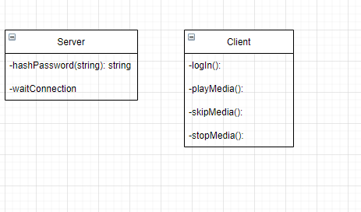

# Test Table

These are an early test table which may change during the testing phase of the program.

|  |  |  |  |  |
| --- | --- | --- | --- | --- |
| Test case | Input | Expected Outcome | Actual Outcome | Comment |
| Test logIn incorrect input |  |  |  |  |
| Test logIn correct input |  |  |  |  |
| Test add media |  |  |  |  |
| Test play song |  |  |  |  |
| Test next song |  |  |  |  |
| Test next song at the last song |  |  |  |  |
| Test previous song |  |  |  |  |
| Test previous song at the first song |  |  |  |  |
| Test output |  |  |  |  |
| Test help files |  |  |  |  |
| Test hashPassword |  |  |  |  |

# Sample unit tests

Some sample unit test will be testing the connection from client to server, testing hashPassword method

# GitHub

https://github.com/kanicc98/Java_MusicPlayer